Game Design Document

Fill up the following document

1. Write the title of your project.

MARIO GAME

1. What is the goal of the game?

To race through the Mushroom Kingdom, survive the main antagonist

Bowser’s forces and save Princess Toadstool.

1. Write a brief story of your game.

A plumber named Mario and his brother Luigi travel through the

Mushroom Kingdom to save Princess from evil Bowser.

1. Which are the playing characters of this game?

* Playing characters are the ones who respond to the user based on the input from the user.
* Cars, monkeys, dinos, wizards, etc., are the playing characters in the game.

|  |  |  |
| --- | --- | --- |
| Number | Character Name | What can this character do? |
| 1 | Mario | Can defeat enemies if he jumps on them |
| 2 |  |  |
| 3 |  |  |
| 4 |  |  |
| 5 |  |  |
| 6 |  |  |
| 7 |  |  |
| 8 |  |  |

1. Which are the Non-Playing Characters of this game?

* Non-Playing characters are the ones that don't have an action or behavior when the user interacts with the game.
* Hurdles, stones, bananas, coins, etc., are non-playing characters in the game.

|  |  |  |
| --- | --- | --- |
| Number | Character Name | What can this character do? |
| 1 | goomba | Moves around and if makes contact with Mario the game is over |
| 2 | castle | The place where princess is to be rescued |
| 3 | Platform | The platform that mario stands/jumps on |
| 4 |  |  |
| 5 |  |  |
| 6 |  |  |
| 7 |  |  |
| 8 |  |  |

Draw your imagination of this game. What does this game look like?

* Draw the game either on your computer or on paper.
* Add images of the game scenes to show each of the playing and non-playing characters at least once.

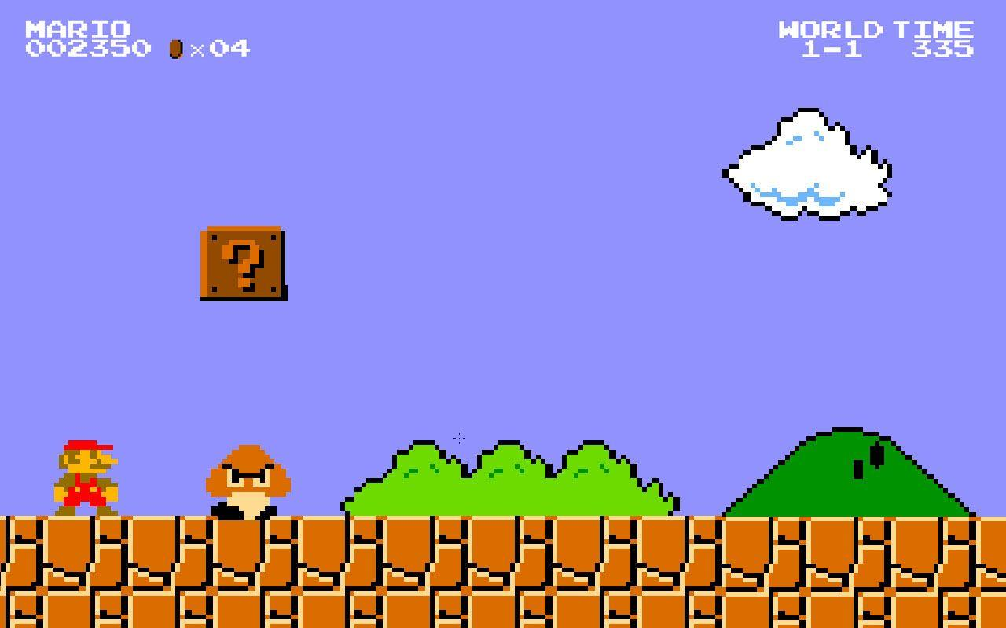

How do you plan to make your game engaging?

The game will have many obstacles to go through in order to reach

And rescue Princess which will lead to victory. The difficulty will increase

Gradually to make the game intresting.